
LESSON NOTE | DETAILED EXPLANATORY NOTES
BIOTECHNOLOGY
THE CONCEPT OF BIOINFORMATICS
GRADE 12 - BIOLOGY
■ ■ ■

What is Bioinformatics?
Bioinformatics is the application of computational and analytic tools to capture and interpret biological data. The Human Genome Project and other sequencing projects have produced an unprecedented amount of biological information - far more than could ever be handled by hand - so bioinformatics uses computers to store, organise, analyse and interpret it. It brings together several subjects: computer science, mathematics, physics and biology, and it has become essential to modern biology and medicine.
This lesson introduces the concept of bioinformatics - what it is, why it is needed, what it does, and how it links to the other topics in this module (the central dogma, DNA sequencing, sequence analysis, and DNA extraction/PCR).
The Fields Bioinformatics Combines
- Biology - the source of the data (DNA, RNA and protein sequences).
- Computer science - for storing, searching and processing huge data sets.
- Mathematics & statistics - for the algorithms that compare and analyse sequences.
- Physics - underlying the instruments and modelling techniques.
Bioinformatics (The Concept)
Key Learning Outcomes
By the end of this lesson, students should be able to:
- Define bioinformatics and explain what it does.
- Explain why bioinformatics is needed (the explosion of biological data).
- Identify the fields that bioinformatics combines.
- Describe the bioinformatics workflow - from data to knowledge.
- Outline the main applications of bioinformatics and how the module's topics connect.
Why Do We Need Bioinformatics?
Modern biology generates enormous amounts of data. A single human genome is about 3 billion base pairs, and sequencing machines can now read many genomes quickly and cheaply. This flood of raw data is far too large to analyse by hand - it must be stored in databases and processed by computers. Bioinformatics meets this demand: it turns raw sequence data into useful biological knowledge, such as identifying genes, their mutations, and their functions.
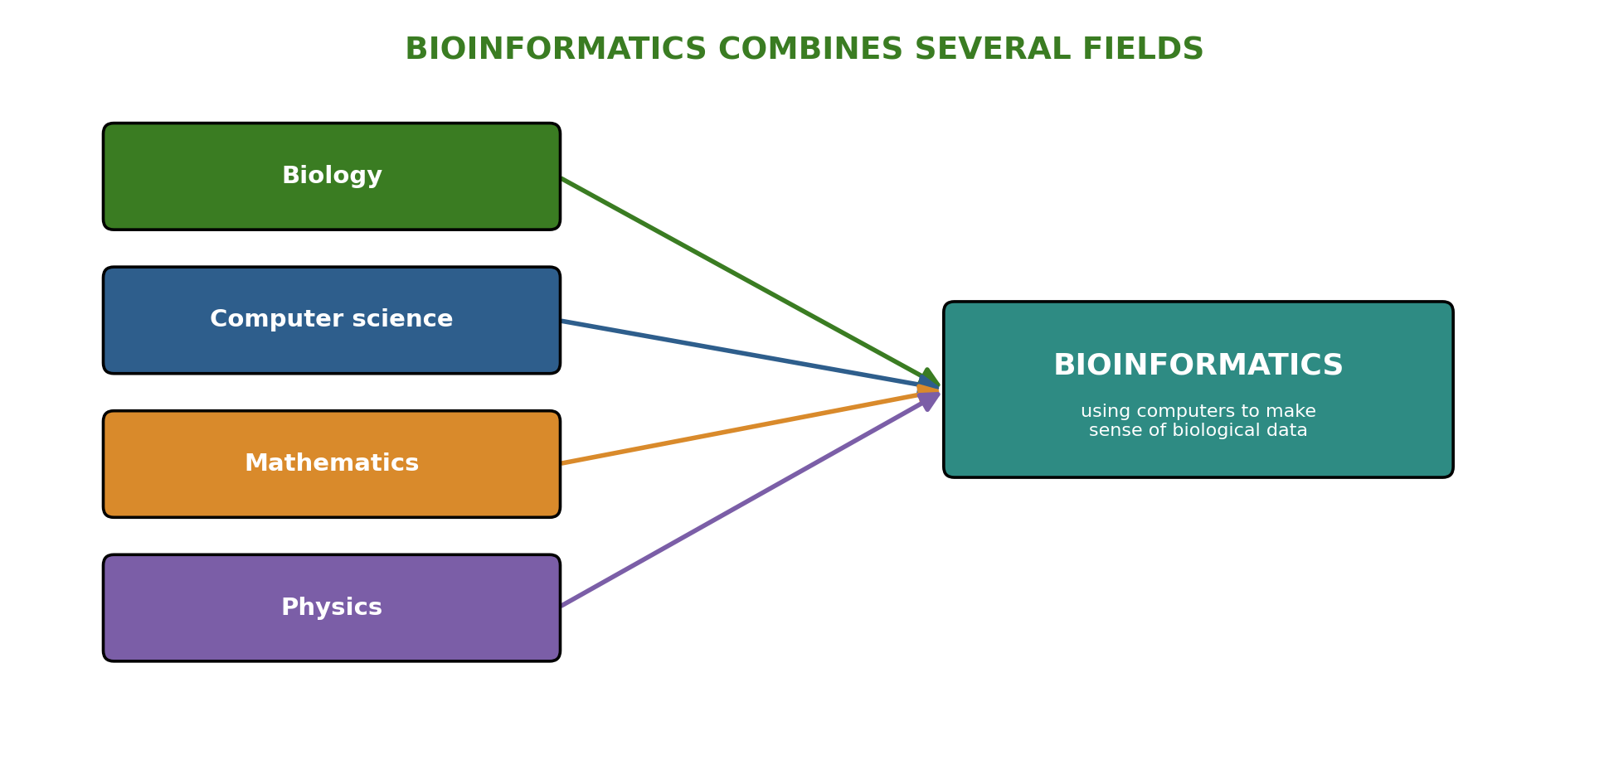
Figure 1: Bioinformatics combines biology, computer science, mathematics and physics.
Terminologies and Concepts
Understanding bioinformatics requires familiarity with several key terms:
- Bioinformatics: applying computational and analytic tools to capture and interpret biological data.
- Biological data: information such as DNA, RNA and protein sequences.
- Database: an organised electronic store of sequences (e.g. GenBank) that scientists can search.
- Sequence: the order of bases (A, T, G, C) in DNA, or of amino acids in a protein.
- Annotation: labelling a sequence with the genes and features it contains.
- Algorithm: a set of steps a computer follows to solve a problem (e.g. comparing sequences).
- Computational biology: using computers and models to study biological systems.
How Bioinformatics Works
Bioinformatics follows a general workflow. Biological data - mostly DNA, RNA and protein sequences - is first stored and organised in databases. Analysis software (such as BLAST and CLUSTAL) is then used to search, compare and interpret the sequences. The result is biological knowledge: the identity and function of genes, the differences between individuals or species, and clues to health and disease. Each step turns raw data into understanding.
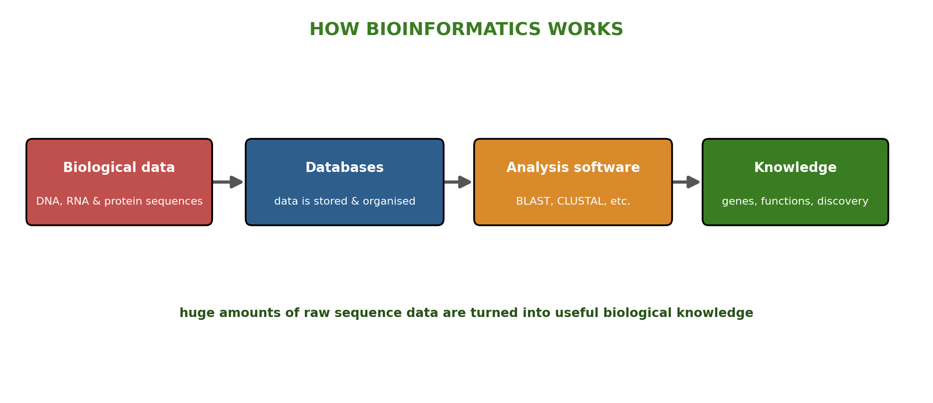
Figure 2: The bioinformatics workflow - biological data is stored, analysed, and turned into knowledge.
What Bioinformatics is Used For
Many areas of biology now rely on bioinformatics:
- Genomics - sequencing and annotating whole genomes.
- Genetics - finding genes and identifying their mutations.
- Medicine - diagnosing disease, tracking pathogens and helping design drugs.
- Evolutionary biology - comparing species to trace common ancestry.
- Gene & protein expression - studying how and when genes are switched on and off.
- Data management - organising and searching biological literature and databases (text mining, ontologies).
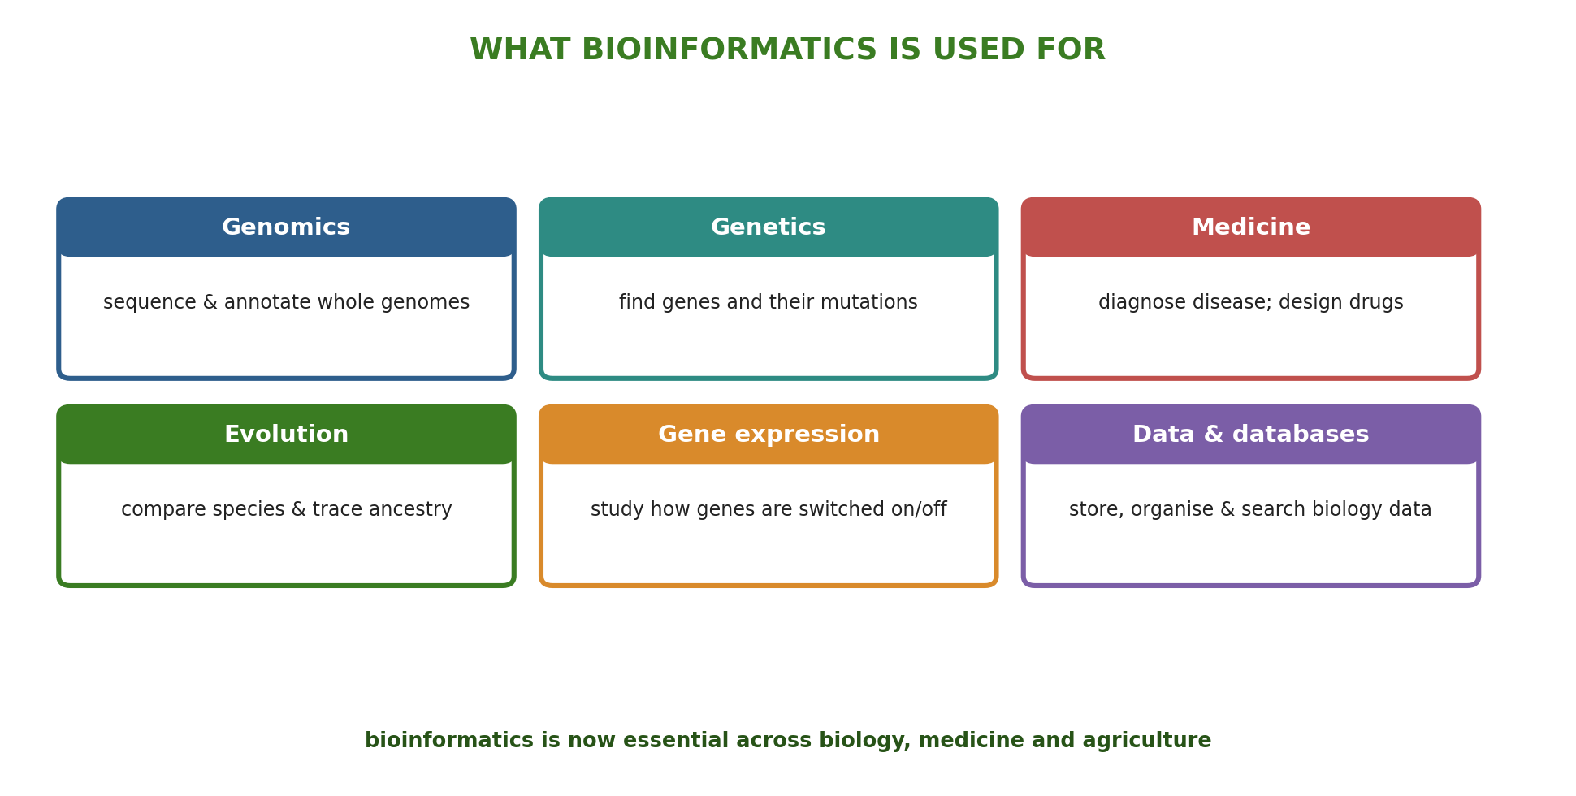
Figure 3: The main applications of bioinformatics across biology and medicine.
Bioinformatics and the Central Dogma
Bioinformatics is built on the central dogma of molecular biology - the flow of information from DNA → RNA → protein. Because genes are stored as sequences of the four bases A, T, G and C, they can be treated as data: read by sequencing, stored in databases, and analysed by computers. Understanding transcription, translation and the genetic code is therefore the foundation for reading and interpreting sequences in bioinformatics.
How the Topics of This Module Connect
Bioinformatics ties the whole module together. The Central Dogma explains how genetic information flows and is expressed. DNA Extraction, PCR and Gel Electrophoresis provide the DNA to work with. DNA Sequencing reads the order of the bases. DNA Sequence Analysis (BLAST and CLUSTAL) then interprets those sequences. Bioinformatics is the computational thread that runs through all of these - storing, analysing and making sense of the data at every step.
Why This Matters
- Handling big data - bioinformatics makes sense of biological data too large for manual analysis.
- Medicine & health - it underpins genetic diagnosis, pathogen tracking and drug discovery.
- Modern research - almost all genetics, genomics and biotechnology now depend on it.
- Careers - it opens pathways in data science, genomics, medicine and biotechnology.
PNG Context Example
Because bioinformatics uses free online tools and public databases, it is within reach of students and scientists in Papua New Guinea. Local researchers can use it to identify and track pathogens such as malaria, tuberculosis and HIV, to study the country's rich biodiversity, and to compare crop and plant sequences - connecting PNG science to the global research community without needing large laboratories.
References & Related Documents
Source Documents
- STEM Biology Student Resource Book - Grade 12, Term 1. Thema: Biotechnology; Module 12.1 Bioinformatics (Module Introduction and Key Concepts). Department of Education, PNG (2021).
- STEM Biology Syllabus - Grade 12, Term 1. Thema: Biotechnology; Module 12.1 Bioinformatics.
- Biology Standards-Based Syllabus, Grades 11 & 12 (PNG SBC 2020) - Strand 2: Life; investigate the structural properties of DNA and its role in heredity and protein synthesis.
Further Reading & References
- National Center for Biotechnology Information (NCBI) - What is Bioinformatics? https://www.ncbi.nlm.nih.gov
- EMBL-EBI - What is bioinformatics? (training). https://www.ebi.ac.uk/training

